WEB X.0 LAB

EXP 1: STUDY WEB ANALYTICS USING OPEN-SOURCE TOOLS LIKE MATOMO, OPEN WEB ANALYTICS, AW STATS, COUNTLY, PLAUSIBLE.

Web analytics is the process of analyzing the behavior of visitors to a website. This involves tracking, reviewing and reporting data to measure web activity, including the use of a website and its components, such as webpages, images and videos.

Data collected through web analytics may include traffic sources, referring sites, page views, paths taken and conversion rates. The compiled data often forms a part of customer relationship management analytics ([CRM analytics](https://www.techtarget.com/searchcustomerexperience/definition/CRM-analytics)) to facilitate and streamline better business decisions.

Web analytics enables a business to retain customers, attract more visitors and increase the dollar volume each customer spends.

The objective of web analytics is to serve as a [business metric](https://www.techtarget.com/searchcustomerexperience/definition/business-metric) for promoting specific products to the customers who are most likely to buy them and to determine which products a specific customer is most likely to purchase. This can help improve the ratio of revenue to marketing costs.

1. matomo

* **Free plan or free trial:** Both.
* **Self-hosted or SaaS tool:** Free version is self-hosted, while the paid version is delivered as a SaaS tool and offers more advanced features and plugins.
* **Quantitative or qualitative analytics:** Quantitative only.
* **User interaction (event) tracking:** Not automatic, has to be set up manually.

Matomo advertises itself as a privacy-friendly web analytics platform. Matomo is built to replace Google Analytics, so it comes with similar quantitative analytics features, as well as limitations in the qualitative analytics department.

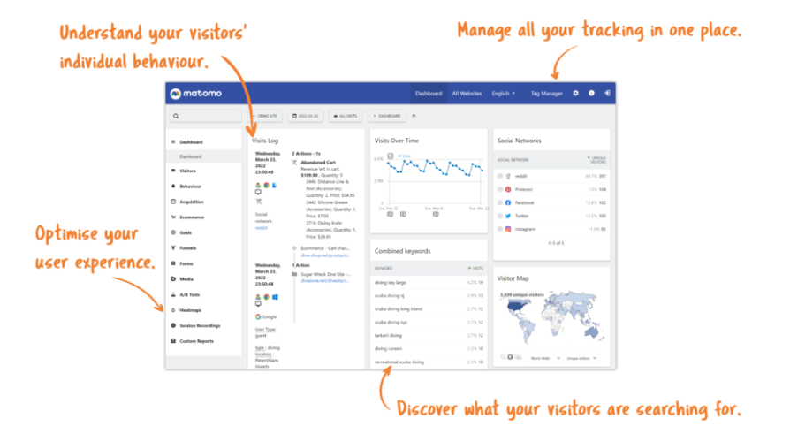

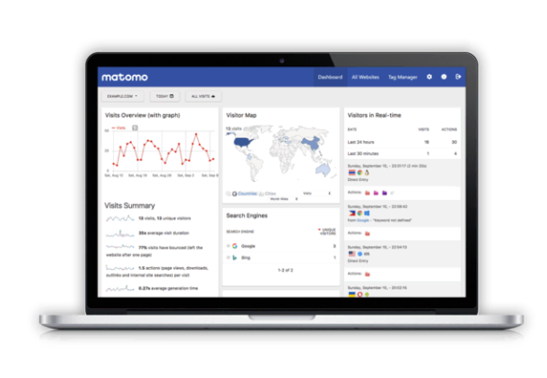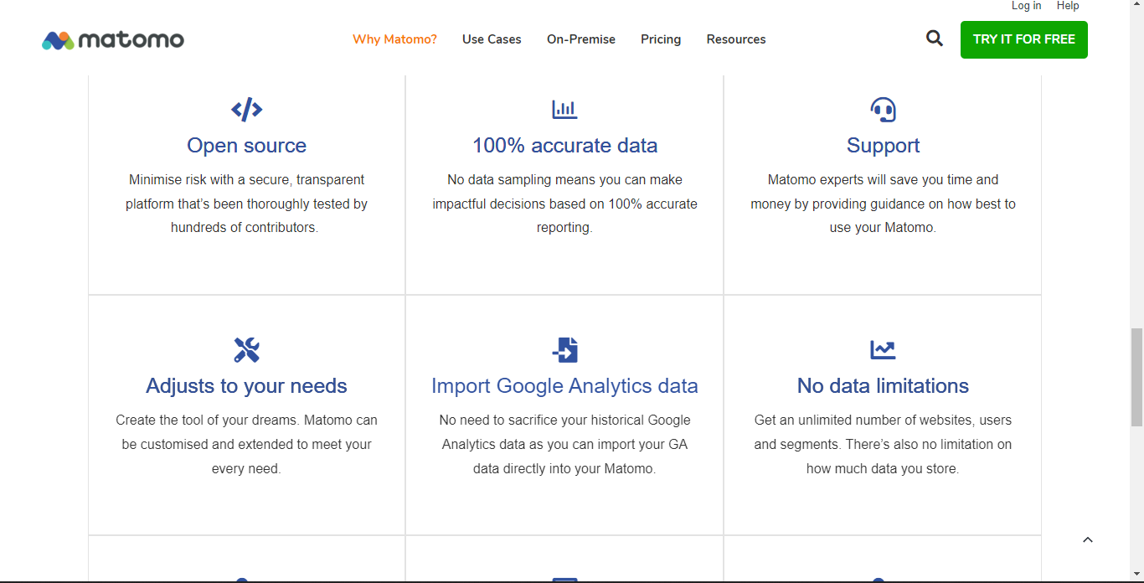

PLAUSIBLE:

### **Plausible Analytics is a compact website analytics tool built for privacy-conscious site owners. The platform offers access to a variety of valuable stats which companies can make use of to improve their end-user experience. Also, Plausible Analytics features a simple set-up and can be integrated with popular tools such as Ghost, WordPress, Wix, Weebly, and Squarespace. Plausible Analytics’s inbuilt API offers a seamless way to retrieve companies' stats programmatically, forward metrics, and present them in different styles as per convenience.**

### **Simple analytics at a glance**

### **Lightweight script that keeps your site speed fast**

### **No need for cookie banners or GDPR consent**

Track events, goal conversions and campaigns

**Invite team members and share your dashboard**

**Transparent and fully open source software**

